# SQL Data Types

Data types are used to represent the nature of the data that can be stored in the database table. For example, in a particular column of a table, if we want to store a string type of data then we will have to declare a string data type of this column.

Data types mainly classified into three categories for every database.

* String Data types
* Numeric Data types
* Date and time Data types

|  |  |
| --- | --- |
| **CHAR(Size)** | It is used to specify a fixed length string that can contain numbers, letters, and special characters. Its size can be 0 to 255 characters. Default is 1. |
| **VARCHAR(Size)** | It is used to specify a variable length string that can contain numbers, letters, and special characters. Its size can be from 0 to 65535 characters. |
| **BINARY(Size)** | It is equal to CHAR() but stores binary byte strings. Its size parameter specifies the column length in the bytes. Default is 1. |
| **VARBINARY(Size)** | It is equal to VARCHAR() but stores binary byte strings. Its size parameter specifies the maximum column length in bytes. |
| **TEXT(Size)** | It holds a string that can contain a maximum length of 255 characters. |
| **TINYTEXT** | It holds a string with a maximum length of 255 characters. |
| **MEDIUMTEXT** | It holds a string with a maximum length of 16,777,215. |
| **LONGTEXT** | It holds a string with a maximum length of 4,294,967,295 characters. |
| **BLOB(size)** | It is used for BLOBs (Binary Large Objects). It can hold up to 65,535 bytes. |

**MySQL Numeric Data Types**

|  |  |
| --- | --- |
| **BIT(Size)** | It is used for a bit-value type. The number of bits per value is specified in size. Its size can be 1 to 64. The default value is 1. |
| **INT(size)** | It is used for the integer value. Its signed range varies from -2147483648 to 2147483647 and unsigned range varies from 0 to 4294967295. The size parameter specifies the max display width that is 255. |
| **INTEGER(size)** | It is equal to INT(size). |
| **FLOAT(size, d)** | It is used to specify a floating point number. Its size parameter specifies the total number of digits. The number of digits after the decimal point is specified by **d** parameter. |
| **FLOAT(p)** | It is used to specify a floating point number. MySQL used p parameter to determine whether to use FLOAT or DOUBLE. If p is between 0 to24, the data type becomes FLOAT (). If p is from 25 to 53, the data type becomes DOUBLE(). |
| **DOUBLE(size, d)** | It is a normal size floating point number. Its size parameter specifies the total number of digits. The number of digits after the decimal is specified by d parameter. |
| **DECIMAL(size, d)** | It is used to specify a fixed point number. Its size parameter specifies the total number of digits. The number of digits after the decimal parameter is specified by **d** parameter. The maximum value for the size is 65, and the default value is 10. The maximum value for **d** is 30, and the default value is 0. |
| **DEC(size, d)** | It is equal to DECIMAL(size, d). |
| **BOOL** | It is used to specify Boolean values true and false. Zero is considered as false, and nonzero values are considered as true. |

**MySQL Date and Time Data Types**

|  |  |
| --- | --- |
| **DATE** | It is used to specify date format YYYY-MM-DD. Its supported range is from '1000-01-01' to '9999-12-31'. |
| **DATETIME(fsp)** | It is used to specify date and time combination. Its format is YYYY-MM-DD hh:mm:ss. Its supported range is from '1000-01-01 00:00:00' to 9999-12-31 23:59:59'. |
| **TIMESTAMP(fsp)** | It is used to specify the timestamp. Its value is stored as the number of seconds since the Unix epoch('1970-01-01 00:00:00' UTC). Its format is YYYY-MM-DD hh:mm:ss. Its supported range is from '1970-01-01 00:00:01' UTC to '2038-01-09 03:14:07' UTC. |
| **TIME(fsp)** | It is used to specify the time format. Its format is hh:mm:ss. Its supported range is from '-838:59:59' to '838:59:59' |
| **YEAR** | It is used to specify a year in four-digit format. Values allowed in four digit format from 1901 to 2155, and 0000. |

### SQL Server Data Types

**SQL Server String Data Type**

|  |  |
| --- | --- |
| **char(n)** | It is a fixed width character string data type. Its size can be up to 8000 characters. |
| **varchar(n)** | It is a variable width character string data type. Its size can be up to 8000 characters. |
| **varchar(max)** | It is a variable width character string data types. Its size can be up to 1,073,741,824 characters. |
| **text** | It is a variable width character string data type. Its size can be up to 2GB of text data. |
| **nchar** | It is a fixed width Unicode string data type. Its size can be up to 4000 characters. |
| **nvarchar** | It is a variable width Unicode string data type. Its size can be up to 4000 characters. |
| **ntext** | It is a variable width Unicode string data type. Its size can be up to 2GB of text data. |
| **binary(n)** | It is a fixed width Binary string data type. Its size can be up to 8000 bytes. |
| **varbinary** | It is a variable width Binary string data type. Its size can be up to 8000 bytes. |
| **image** | It is also a variable width Binary string data type. Its size can be up to 2GB. |

**SQL Server Numeric Data Types**

|  |  |
| --- | --- |
| **bit** | It is an integer that can be 0, 1 or null. |
| **tinyint** | It allows whole numbers from 0 to 255. |
| **Smallint** | It allows whole numbers between -32,768 and 32,767. |
| **Int** | It allows whole numbers between -2,147,483,648 and 2,147,483,647. |
| **bigint** | It allows whole numbers between -9,223,372,036,854,775,808 and 9,223,372,036,854,775,807. |
| **float(n)** | It is used to specify floating precision number data from -1.79E+308 to 1.79E+308. The n parameter indicates whether the field should hold the 4 or 8 bytes. Default value of n is 53. |
| **real** | It is a floating precision number data from -3.40E+38 to 3.40E+38. |
| **money** | It is used to specify monetary data from -922,337,233,685,477.5808 to 922,337,203,685,477.5807. |

**SQL Server Date and Time Data Type**

|  |  |
| --- | --- |
| **datetime** | It is used to specify date and time combination. It supports range from January 1, 1753, to December 31, 9999 with an accuracy of 3.33 milliseconds. |
| **datetime2** | It is used to specify date and time combination. It supports range from January 1, 0001 to December 31, 9999 with an accuracy of 100 nanoseconds |
| **date** | It is used to store date only. It supports range from January 1, 0001 to December 31, 9999 |
| **time** | It stores time only to an accuracy of 100 nanoseconds |
| **timestamp** | It stores a unique number when a new row gets created or modified. The time stamp value is based upon an internal clock and does not correspond to real time. Each table may contain only one-time stamp variable. |

**SQL Server Other Data Types**

|  |  |
| --- | --- |
| **Sql_variant** | It is used for various data types except for text, timestamp, and ntext. It stores up to 8000 bytes of data. |
| **XML** | It stores XML formatted data. Maximum 2GB. |
| **cursor** | It stores a reference to a cursor used for database operations. |

**Creation of Table Without Constarints:**

**create database viyas;**

**use viyas;**

**Creation of Table**

**create table cars(sno int, name varchar(20));**

**describe cars;**

**insert into cars values(2,'Chevrolet'),(3,'Dodge'),(4,'Hennessey Venom');**

**select * from cars;**



**Create table from Another table**

**create table four_wheelers(select * from cars);**



**Creating Table With AUTO_INCREMENT Constraint :**

**Note:** Autoincrement increments the column value automatically, initaially it assigns value 1

create table stocks(sno int primary key auto_increment , sname varchar(30));

describe stocks;



insert into stocks(sname) values('Eclairs'),('Oreo'),('Kitkat');

select * from stocks;



**Check constraint**  
  
Create table Persons(id int not null,name varchar(45) not null,age int not null check(age>=18));  
  
insert into Persons(id,name,age) values(1,'smriti',22),(2,'hema',35),(3,'amit',40);  
insert into Persons(id,name,age) values(1,'rahul',13);

select*from Persons;

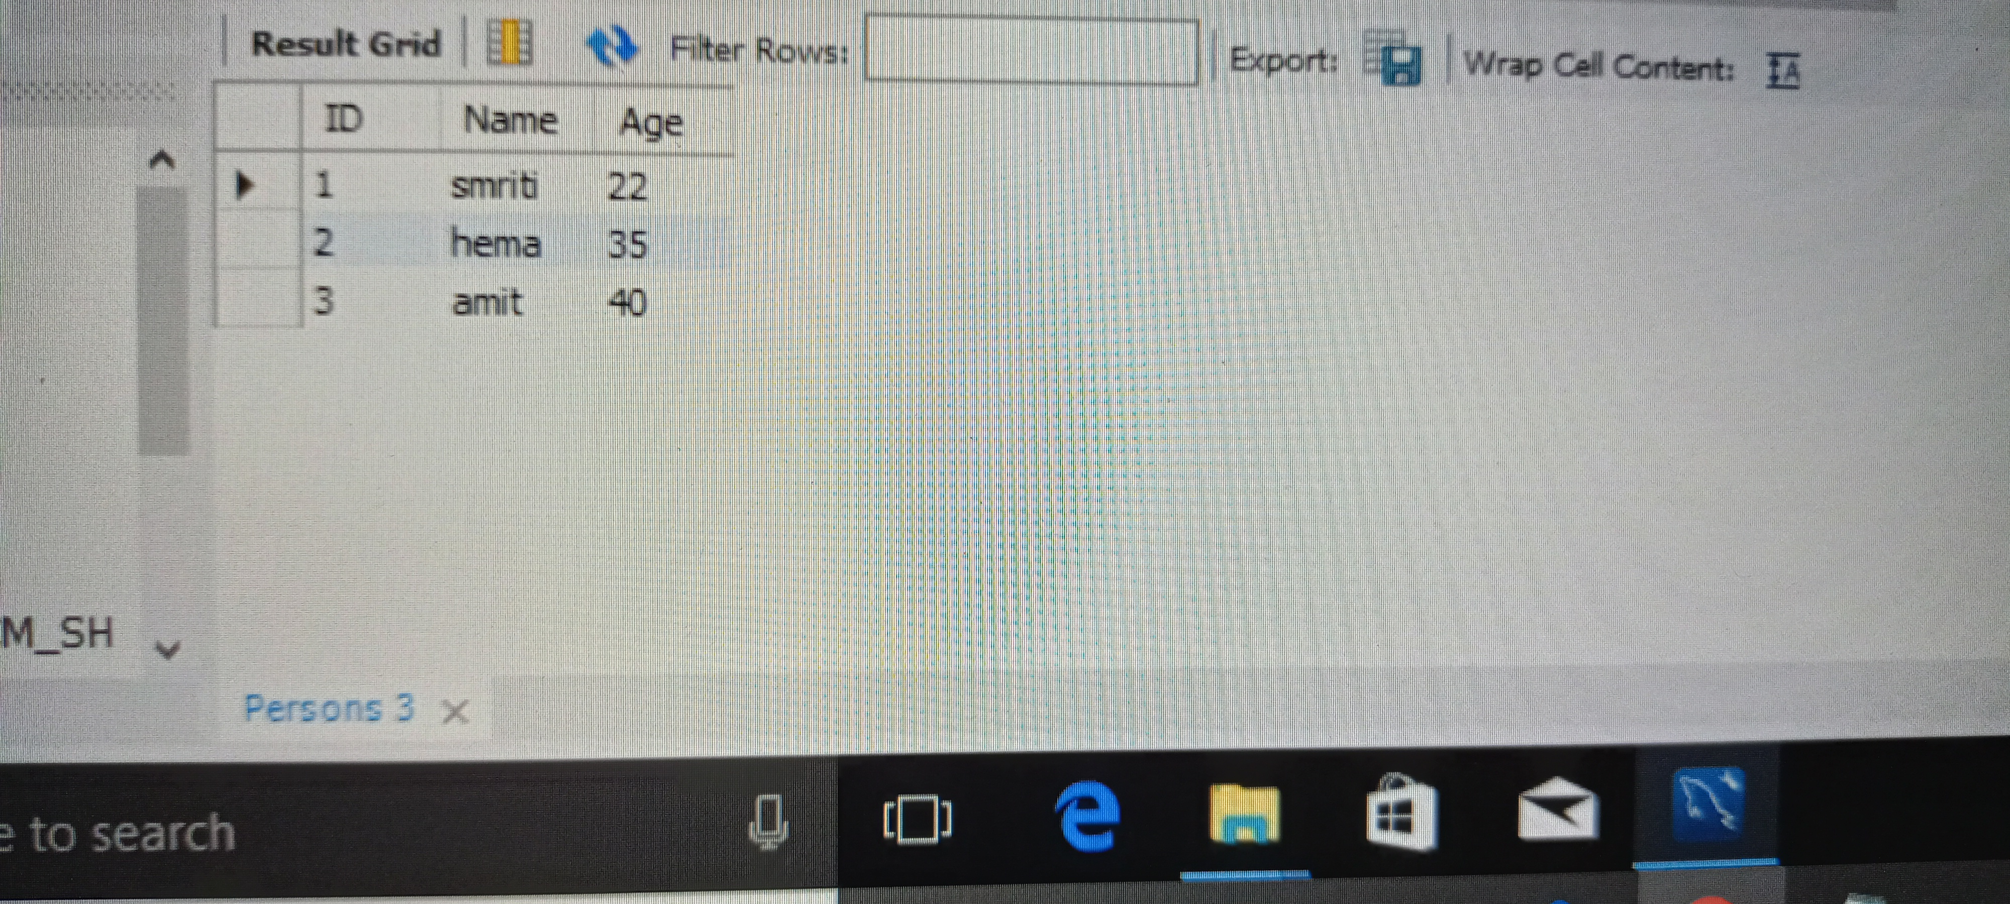

**Default constraint**  
  
Create table places(id int not null,name varchar(30) not null,age int,city varchar(20)

default 'mumbai');  
  
insert into places(id,name,age,city)  
values(1,'shristi','22,'jharkhand'),(2,'neha',21,'Delhi'),(3,'Sana',35,'kolkata');   
  
insert into places(id,name,age)  
values(1,'sneha',36);  
select * from tables;

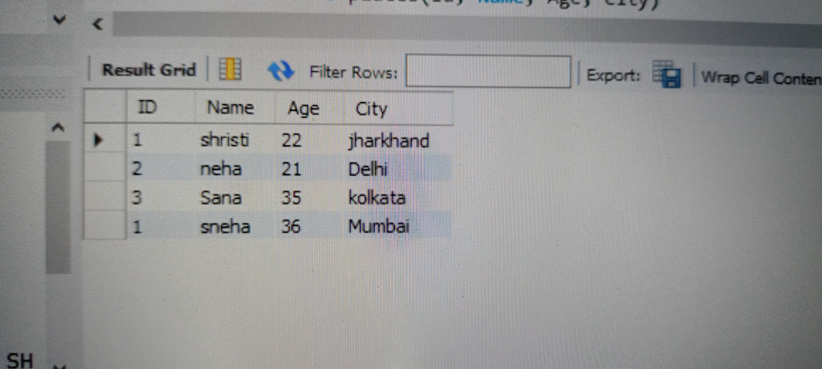

**NOT NULL Constraint :**

create database tasmiya;

use tasmiya;

create table customer1 ( cid int primary key,cname varchar(30) not null,caddress varchar(20) default 'bangalore',cphone int not null);

desc customer;

drop table customer;

insert into customer1 values(1,"tasmiya","ckm");

insert into customer1 (cid,cname,cphone) values(2,"priya",4567);

select * from customer1;

truncate customer1;

drop table customer1;

**UNIQUE CONSTRAINT**

The UNIQUE constraint creates an index such that, all values in the index column must be unique. An error occurs when any body tries to add a new row with a key value that already exists in that row.

CREATE TABLE Persons (

ID int NOT NULL,

LastName varchar(255) NOT NULL,

FirstName varchar(255),

Age int,

UNIQUE (ID)

);

UNIQUE Constraint on ALTER TABLE

To create a UNIQUE constraint on the "ID" column when the table is already created, use the following SQL:

ALTER TABLE Persons

ADD UNIQUE (ID);

**PRIMARY KEY**

The PRIMARY KEY constraint uniquely identifies each record in a table.

Primary keys must contain UNIQUE values, and cannot contain NULL values.

A table can have only ONE primary key; and in the table, this primary key can consist of single or multiple columns (fields).

The following SQL creates a PRIMARY KEY on the "ID" column when the "Persons" table is created:

**MySQL:**

CREATE TABLE Persons (

ID int NOT NULL,

LastName varchar(255) NOT NULL,

FirstName varchar(255),

Age int,

PRIMARY KEY (ID)

**SQL PRIMARY KEY on ALTER TABLE**

To create a PRIMARY KEY constraint on the "ID" column when the table is already created, use the following SQL:

ALTER TABLE Persons

ADD PRIMARY KEY (ID);

**To drop a PRIMARY KEY constraint, use the following SQL:**

**MySQL:**

ALTER TABLE Persons

DROP PRIMARY KEY;

**FOREIGN KEY**

FOREIGN KEY constraint is used to prevent actions that would destroy links between tables.

A FOREIGN KEY is a field (or collection of fields) in one table, that refers to the PRIMARY KEY in another tabl**e.**



**SQL FOREIGN KEY on CREATE TABLE**

**The following SQL creates a FOREIGN KEY on the "PersonID" column when the "Orders" table is created:**

**MySQL:**

CREATE TABLE PERSON(

PersonID int NOT NULL,

primary key (PersonID)

);

CREATE TABLE Orders (

OrderID int NOT NULL,

OrderNumber int NOT NULL,

PersonID int,

PRIMARY KEY (OrderID),

FOREIGN KEY (PersonID) REFERENCES PERSON(PersonID)

);

Desc Orders;

**SQL FOREIGN KEY on ALTER TABLE**

To create a FOREIGN KEY constraint on the "PersonID" column when the "Orders" table is already created, use the following SQL:

ALTER TABLE Orders

ADD FOREIGN KEY (PersonID) REFERENCES Persons(PersonID);

To allow naming of a FOREIGN KEY constraint, and for defining a FOREIGN KEY constraint on multiple columns, use the following SQL syntax:

ALTER TABLE Orders

MySQL:

ALTER TABLE Orders

DROP FOREIGN KEY FK_PersonOrder;

ALTER TABLE Orders

DROP CONSTRAINT FK_PersonOrder;